

Dear Registrants and Members
October Chair’s Share

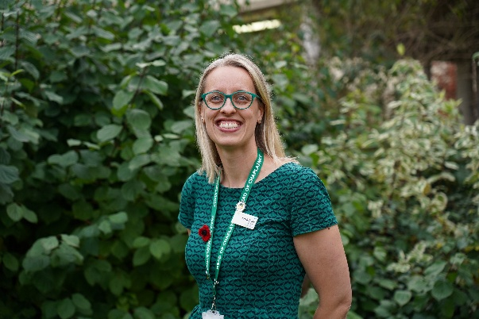

This is a full Chair’s Share with a range of updates, information and requests. Below you will find details of our new name, an update on changes to how fees will be collected next year, a reminder of director positions currently vacant and opportunities to get involved with various of our current workstreams.

Name Change
We were delighted earlier this year to have had over 100 responses to our request for feedback which helped to shape our decision making. Following the September Board meeting a small group made a final decision settling on the Council for Professional Chaplains and Pastoral Carers.

The term council was chosen as it follows that of other registry bodies in the UK. From a public safety perspective, without chaplain being a protected title, incorporating professional reflects the high level of formal, training, specialized knowledge, and advanced skills required to be a chaplain. This echoes other bodies, such as in the USA with the Association of Professional Chaplains. Feedback indicated both that, as the inherited name, chaplain was important to keep, but that pastoral carer is a term preferred by those who find chaplains associations less helpful. The new name will form a key part of an updated logo as part of the rebranding work being supported by Adept Design. We hope this will be ready to be revealed early in the new year.

Payment of Fees and Annual CPD Returns
I’m grateful for the work that Janelle, as our Registration Lead and Vice Chair, has done over this past year, including supporting the switch to using GoCardless for recurring membership and registration fees. This update is from her. From 2026, we will move all registrants and members to a rolling membership start/end date, commensurate with the date of their fee payment. The date that you set up your GoCardless mandate will be your new annual membership start date. If you have not set up a GoCardless mandate, you will receive an email early in the new year to pay your 2026 fees.

Reminders will be sent from the GoCardless system. If your payment fails, you will be responsible for initiating a new payment within four weeks. For those whose payment is not via the GoCardless system, you will receive a reminder from the UKBHC to submit payment within 4 weeks via another approved method. As with CPD returns (see below), the same rhythm of suspension and removals – four and eight weeks after due date – will apply.

As approved by the Directors in September the following fee increases will apply for 2026:
- Full Registration – £65
- Associate Membership - £65
- Affiliate Membership - £32.50
- Student Membership - £32.50
- Senior Associate Membership - £11.25

The annual CPD return will remain the same for 2026 with returns for CPD activity through 2025 due on 1st February 2026. An updated form will be available on the UKBHC website shortly.

Director Vacancies
A reminder that there is an advert out for new directors, both professional and lay. The closing date is Friday 31st October so please do consider whether this might be for your or for someone you know, particularly the lay director roles which need to be held by those not working in the profession who are able to offer HR, legal or financial expertise etc.

Opportunities for Involvement
There are a number of areas where I invite your involvement:

- To support our work around better recruitment processes we are putting together a small working group to create standardized job description templates to accompany the person specification developed a few years ago. If you’d be interested in being part of this group please let me know: Chair@ukbhc.org.uk

- The Capability, Comfort, and Calm outcome measurement framework developed by Elizabeth Teisberg and Scott Wallace aims to measure the outcomes that matter most to people. Capability measures a patient’s functional status. Comfort measures relief from physical and emotional pain. Calm measures chaos and disruption of everyday life experienced during the course of care . As part of our work evidence value of chaplaincy, we are keen to collect short examples, no more than 3 sentences, of where care has contributed to one of the above outcomes. Please send examples to Helena, our admin: admin@ukbhc.org.uk

- Through 2026 we will be exploring ways of making the CPD return more of a supportive process. If you’d be interested in being part of a pilot group trialling a new way please contact Janelle: registration.lead@ukbhc.org.uk

Lastly, thank you for reading through this update. In a few weeks Directors will have an overnight residential meeting in Edinburgh. If there are things that you would wish us to discuss or take note of please do contact me – chair@ukbhc.org.uk.

With best wishes,

Sarah

Sarah Crane (she/her/hers)

UKBHC Chair
Chair@ukbhc.org.uk

