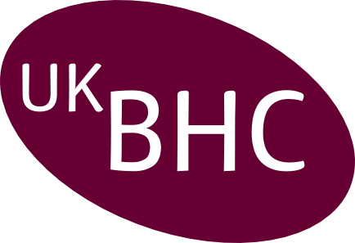
Annual Summary of
Chaplaincy CPD 2020

Name:
Designation:
Organisation:

Category | Examples | Impact of Learning on Practice | CPD hours
Individual:
Self-directed learning
Individual:
Professional activity
Internal:
Work-based learning
External:
Formal educational activity

Annual summary forms should be returned by 28th February 2021.

Post: Box 105, Addenbrooke’s Hospital, Cambridge CB2 0QQ,
Email: chaplaincy@addenbrookes.nhs.uk

Please retain a copy of this report for your CPD portfolio

