UKBHC Board Member profile
Brief account of your experience to date:
Mark Stobert is a Methodist Minister, in Circuit Ministry since 1989 and ordained in 1991.
He has been Lead Chaplain at Cambridge University Hospitals NHS Foundation Trust since November 2018.
He was Chaplaincy Team Leader in Dudley Group Healthcare NHS Foundation Trust from 1995 until 2018.
In that time he has developed an interest in models of trauma support and in reflective practice as a paradigm for professional artistry. He facilitates reflective supervision groups.
Mark has an MA in Psychodynamic Counselling and is a member of British Association of Counselling and Psychotherapy. He is currently engaged on the Doctorate of Practical Theology program at the University of Birmingham. His doctorate is entitled Safe Space for Slow Questions.
Mark was a regional representative on the National Professional Council (NPC) of the College of Health Care Chaplains (CHCC) and president of CHCC from 2010 to 2012.
Any role you fulfil on the Board:
Mark is Chair of the board and was appointed at the December 2018 meeting.
Mark has been a board member as president of CHCC from its inception and since 2012 fulfilled the role of secretary to the UKBHC.
He is also a member of the working group that completed the UKBHC’s successful application to be a recognised voluntary register to the Professional Standards Authority (PSA).
UKBHC gained Recognised Register status with PSA in August 2017.
What you hope to contribute to the work of UKBHC:
Mark hopes to contribute through experience and insight to the vision for the future of chaplaincy as a vital and vibrant professional constituent of healthcare.
He recognises that chaplains respond to the existential needs of the public and as such
he also hopes to continue to contribute by fulfilling the role of chair.
Photograph:
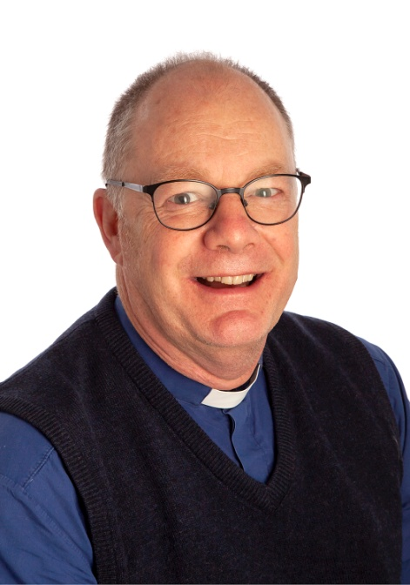
Name: Rev Mark Stobert

