UKBHC Board Member profile
Brief account of your experience to date:

Before Healthcare Chaplaincy Mark Rodgers worked for 17 years as a Minister in the Presbyterian Church in Ireland , for most of that time in a single congregation in Co Down . He trained for the Ministry in Aberdeen. Mark worked part-time as a denominational chaplain in his native N. Ireland for a number of years before being appointed a Full-Time Chaplain with NHS Grampian in 2003, based in Aberdeen Royal Infirmary. He served on the Executive of the Scottish Association of Healthcare Chaplains from 2007-2010. He was in very first cohort of students for the Glasgow University Post-Graduate Certificate in Healthcare Chaplaincy in 2010, graduating in 2011. In 2012 he was appointed Lead Chaplain and Head of Service for NHS Grampian. This post brings membership of the Professional Leads Group for Chaplaincy in Scotland .

Any role you fulfil on the Board:

Registrar

What you hope to contribute to the work of UKBHC:

Mark combines experience in part time and full Chaplaincy , along with experience of a denominational, in his case Presbyterian, and generic model of chaplaincy . He is also aware of the demands associated with obtaining a post-graduate qualification in Healthcare Chaplaincy . Therefore he would like to adhere to the requirements the Board requires for Registration in a consistent but sensitive manner, recognising the diversity of Chaplaincy experiences throughout the UK .

Photograph:

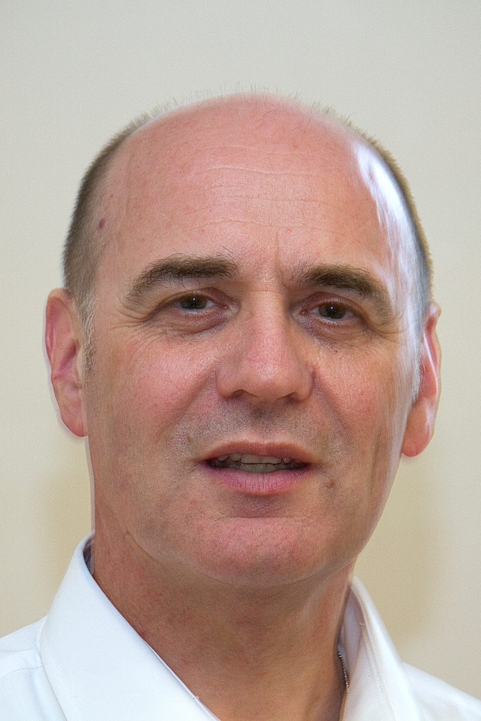

Name (including qualifications):
Rev Mark Rodgers BA, BD, M.Th. PG Cert (HC)

