UKBHC Board Member profiles
Brief account of your experience to date:
Derek has been a Methodist minister in Northern Ireland since 1989. He has served in 3 different circuits for 4, 6 & 5 years respectively. During his 3rd appointment (1999-2004) he became a part time chaplain at the Royal Group of Hospitals, Belfast. In 2004 Derek became full-time Co-ordinating Chaplain at the Royal. In 2008 he became Lead Chaplain of the newly created Belfast Health & Social Care Trust, managing a team of almost 40 chaplains across 7 hospital sites. He also retains a pastoral chaplaincy role on the Royal Hospitals site.
Derek was the Director of Training of the NI Healthcare Chaplains' Association (NIHCA) from 2007 - 2018. This included arranging training for chaplains; linking with Faith communities; and linking with the Dept of Health NI.
He is Convenor of the Methodist Church in Ireland Prison & Healthcare Chaplaincy Committee since 2005.
Qualifications - BD (Hons) Queens' University Belfast (1991)
- MA (Healthcare Chaplaincy) University of Leeds (2002)

Any role you fulfil on the Board:
Derek has been a member of the Board since its inception in 2008, initially as a senior officer of the NIHCA and as Secretary to the Board from 2018.

What you hope to contribute to the work of UKBHC:
Derek brings the perspective of having worked both in part time & full time chaplaincy capacities. He also brings the NI perspective to the UK scene. He is convinced of the need for chaplaincy to hold together, promote and develop both the vocational/faith and professional agendas

Photograph:

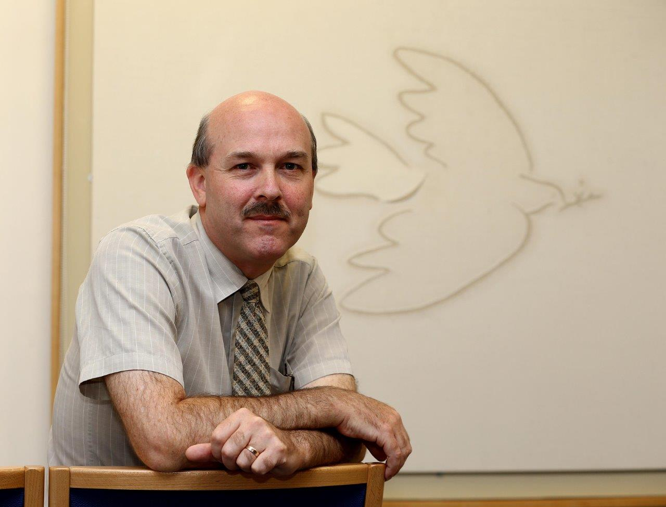

Name:

Rev Derek Johnston BD MA

