UKBHC Board Member profiles
Brief account of your experience to date:
After a brief career in banking Derek trained for ministry at Glasgow University.
He served for 17 years as a Baptist minister in Scotland and England before entering health care chaplaincy in 1994 as one of the Chaplains at Leeds General Infirmary. He moved to Cambridge University Hospitals NHS Trust in 2001 as Lead Chaplain and Bereavement care lead and since November 2018 is one of the senior chaplains there, working 3 days a week.

Any role you fulfil on the Board:
Derek acted as Chair of the board from its inception until 2017 and now acts as Lead officer for the academic standards strand of the Board’s work.

What you hope to contribute to the work of UKBHC:
Derek is delighted that the goal of the UKBHC as the regulator for heath chare chaplaincy has been realised. He is keen to see the professional standards especially in relation to the academic dimensions developed and made robust. He suggests that the profession lacks a significant amount of that kind of infrastructure and is keen to develop that aspect. The educational development of chaplains is key to its growth and sustainability.

Photograph:

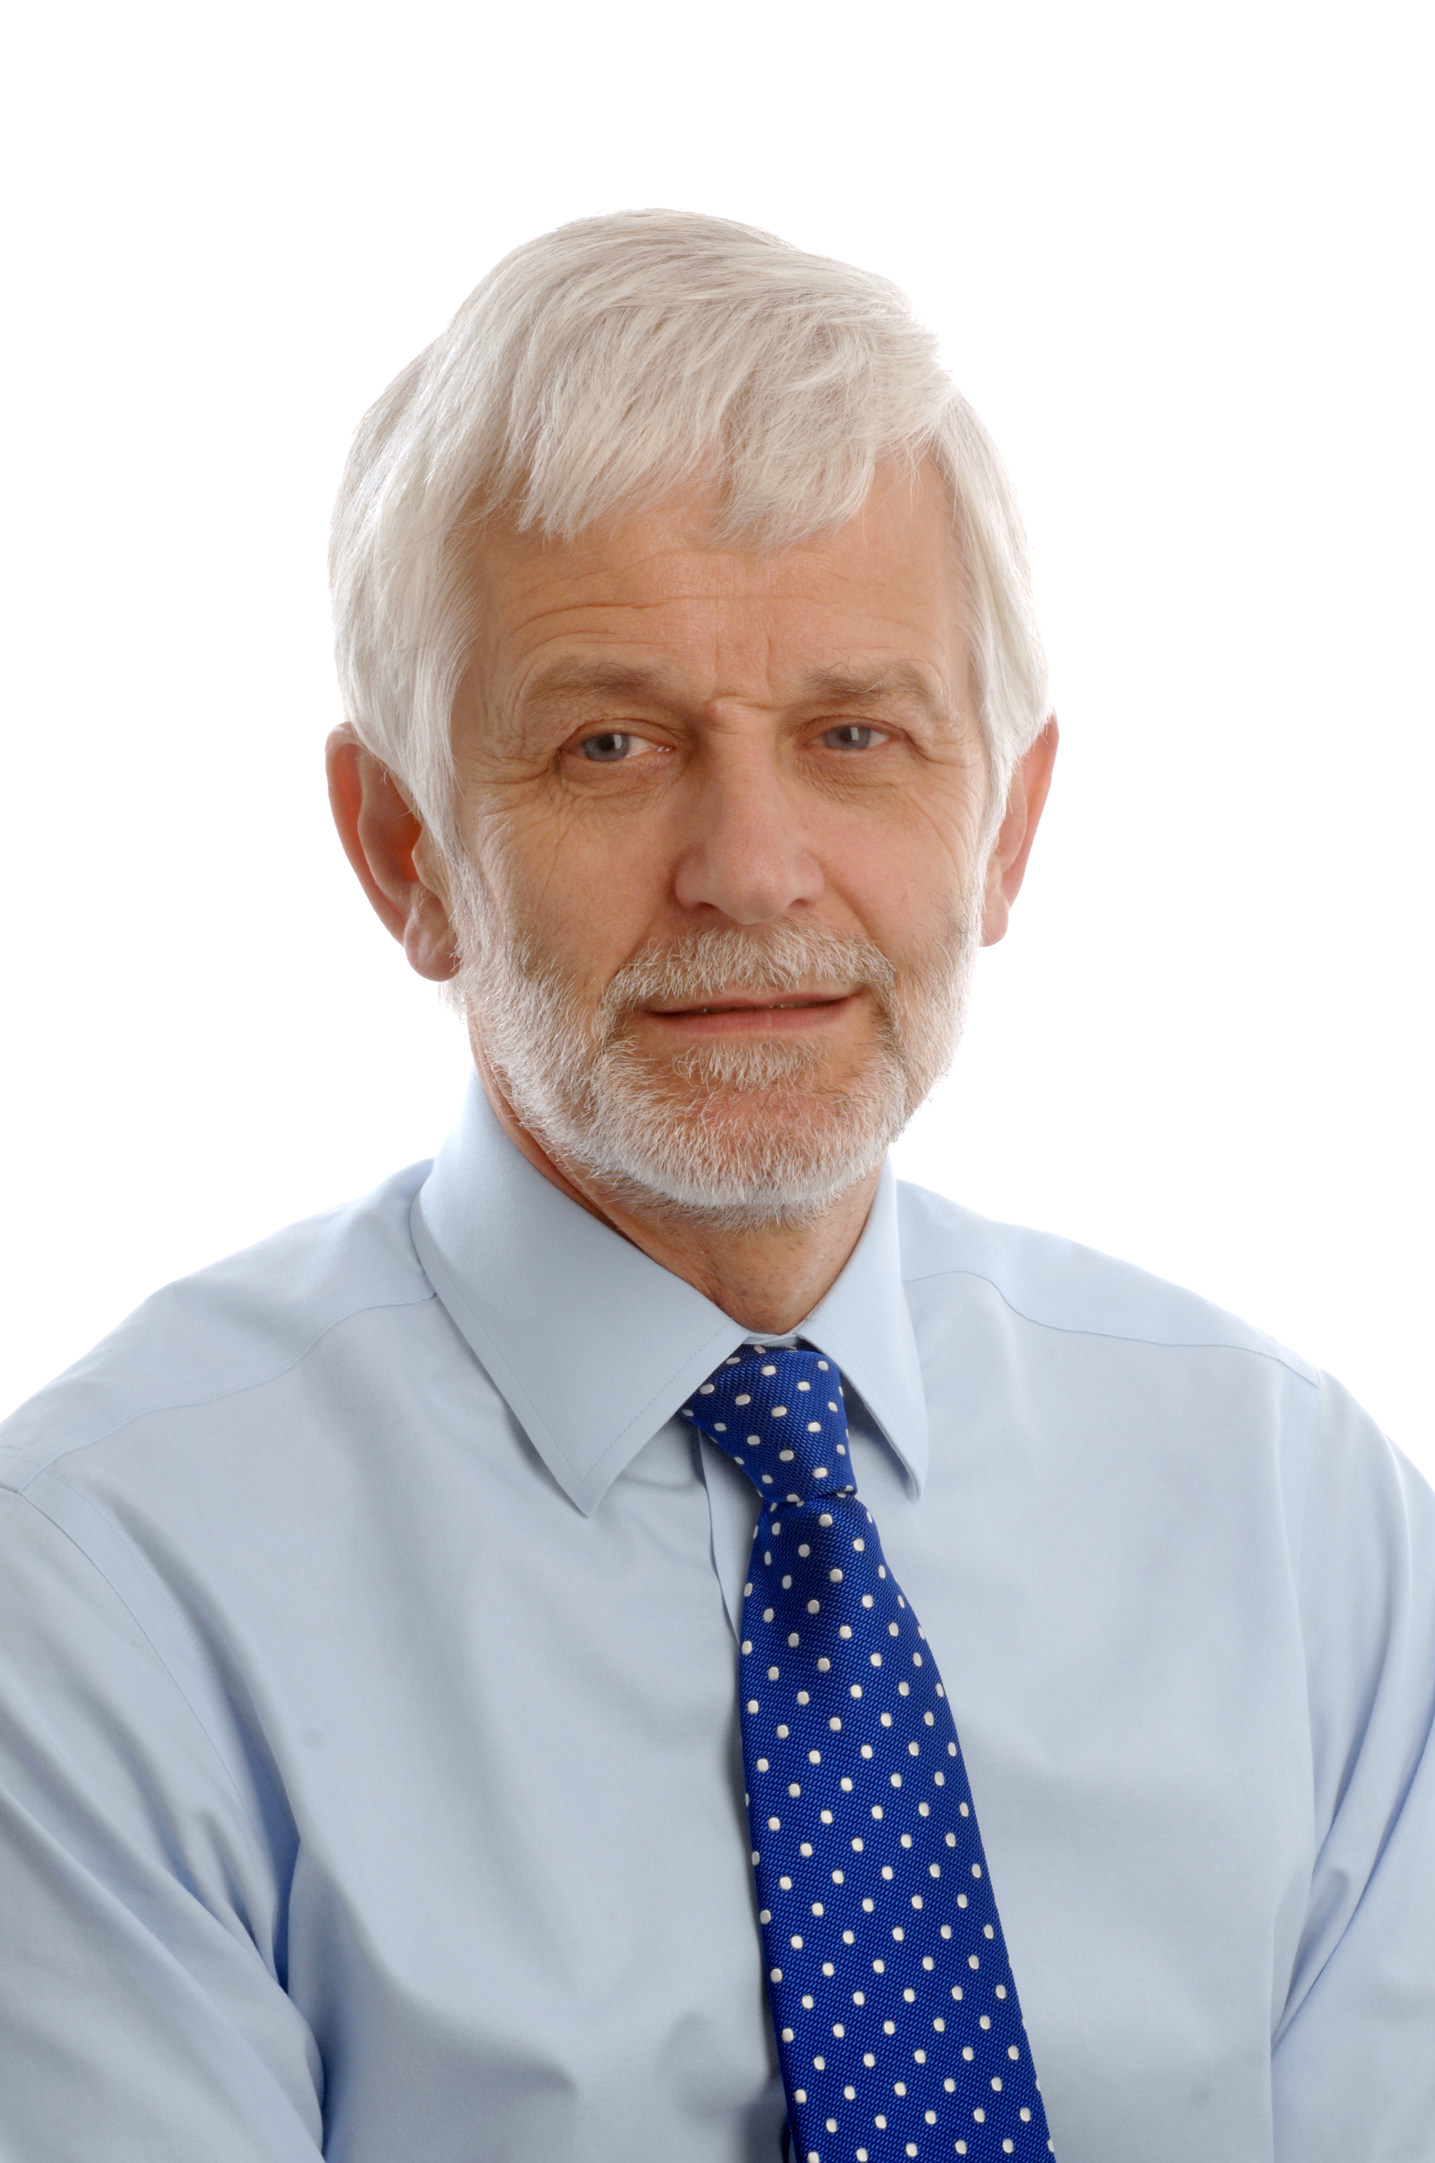

Name:
Revd Dr Derek J Fraser BD PhD

