UKBHC Board Member profiles 2019
Brief account of your experience to date:

I have been involved in chaplaincy in Devon since 1997, both acute and mental health. During that time I have worked in almost every different type of chaplaincy capacity; volunteer, bank chaplain, locum chaplain, assistant chaplain, specialist chaplain and lead chaplain. I have spent several years supporting the work of the College of health care chaplains (CHCC) at a national level.

Any role you fulfil on the Board:

As the current President of CHCC I am automatically a member of the board.

What you hope to contribute to the work of UKBHC:

I am very keen to ensure that the work of UKBHC and the work of CHCC as a professional body is harmonious and distinct, each bringing their particular function to bear on the improvement of chaplaincy as a profession.

My keen area of interest relates to the means by which people enter into the profession from a diverse range of backgrounds.

Photograph:

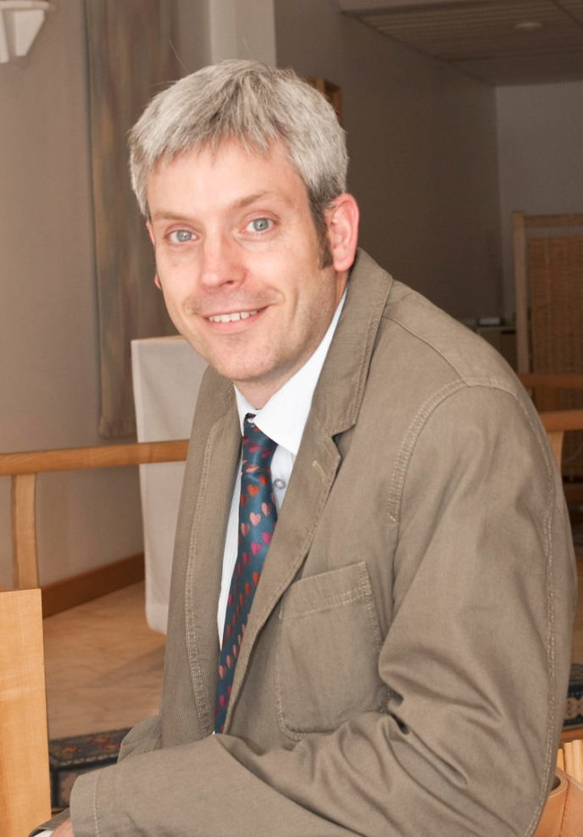

Name (including qualifications):
Dr Simon Harrison TSSF

