UKBHC Board Member profile 2019
Brief account of your experience to date:
Simon has been in healthcare chaplaincy since 2003. He has worked as Chaplain at University Hospitals Coventry & Warwickshire NHS Trust since 2004 and became lead chaplain & Bereavement Service Manager in 2010. Over the last 16 years he has specialised in neonatal loss and mental health. Over the last 5 years he has been involved with and led various new initiatives mainly within the community. These include services to tackle social isolation and anxiety for patients with long term conditions. In 2017 he started a Compassionate Community project providing support for patients approaching the end of their life and their families, and bereavement support in the community. Simon is Chair of the Joint Health & Wellbeing Group in Rugby.

For a number of years Simon was the CHCC representative for the West Midlands and has represented chaplaincy on one of the Archbishops’ Task groups and other groups within the Church of England.

Any role you fulfil on the Board:
Convene Fitness to Practice Screening Committee as necessary.

What you hope to contribute to the work of UKBHC:
I hope to bring a different experience of chaplaincy and help promote high standards within our profession while encouraging innovation and creativity.

Photograph:

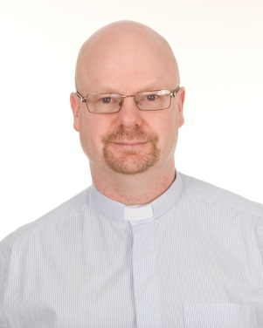

Name (including qualifications): Rev Simon Betteridge, BA Theology

