UKBHC Board Member profiles
Brief account of your experience to date:
Since being ordained a priest in 2005, Fr Robert has worked in several ministries (formation, education, parish) in various countries. In 2014 he took up the role of full-time Catholic Chaplain at the Royal Hospitals in Belfast: Royal Victoria Hospital, the Royal Jubilee Maternity, and the Belfast Hospital for Sick Children. He forms part of a great energetic multi-denominational team of chaplains who tend to patients, families and staff at these hospitals. In 2015 Fr Robert became a vice-president of the Northern Ireland Healthcare Chaplains' Association Executive Committee (NIHCA) and then President from May 2019. In 2016 he became a Committee member of the Support Network for Catholic Healthcare Chaplains (SNCHC) and since 2018 is a registered chaplain and serves as a board member of the Healthcare Chaplaincy Board (HCB) Ireland.

Any role you fulfil on the Board:
Fr Robert has recently been appointed to the board of the UKBHC in December 2018. He sits as a director on the board to represent the Northern Ireland Healthcare Chaplains Association (NIHCA).

What you hope to contribute to the work of UKBHC:
As the board continues to grow from strength to strength after achieving Professional Standards Authority recognition, and seeks to increase membership and better training standards for chaplains, Fr Robert hopes to be able to help bring the perspective of chaplaincy in Northern Ireland and Ireland to the board.

Photograph:
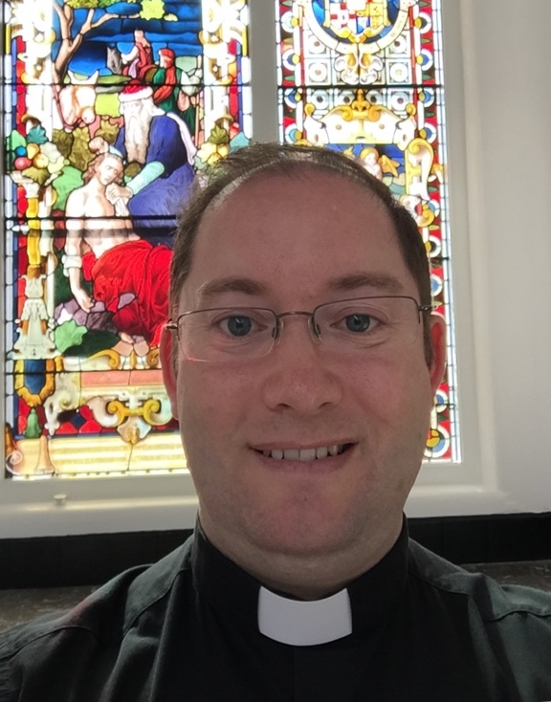

Name (including qualifications):
Fr Robert Sloan

