UKBHC Board Member profiles
Brief account of your relevant experience to date:

I am a Methodist Minister with 30 years experience of pastoral care. I started my hospice work as a volunteer chaplain in 1998 and took up my current role as full time chaplain and spiritual lead in 2005. Weston Hospicecare is a 10 bedded unit in Weston super Mare but serves a large rural catchment area. I am part of a Family Support Team which co-ordinates chaplaincy, bereavement and volunteer support for patients and families.

Any role you fulfil on the Board:

I am currently in my second term as President of the Association of Hospice and Palliative Care Chaplains. This organisation supports spiritual care providers in NHS and independent hospices.

My role on UKBHC is to represent the specific responsibilities of chaplains working in palliative care.

What you hope to contribute to the work of UKBHC:

I have been involved in and aware of UKBHC for many years along side those who have really pushed the goals forward. Having achieved so much for the profession, my aim is to continue to promote the role of UKBHC to our members and encourage engagement with the voluntary register, training and the overall goals.

Photograph:

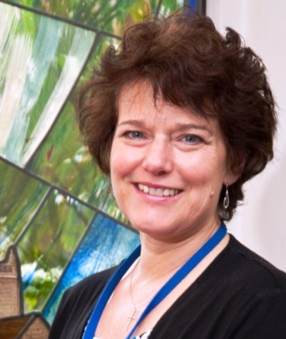

Name (including qualifications):

Rev. Karen Murphy B.Sc (Econ)

