UKBHC Board Member profile 2019
Brief account of your relevant experience to date:
Currently I am Head of Spiritual and Pastoral Care at South London and Maudsley NHS Foundation Trust. I have been involved in mental health chaplaincy for over 20 years, as Head of Service at Greater Glasgow and Clyde NHS Partnerships and Lancashire Teaching Hospitals NHS Foundation Trust, having previously worked as a Church of Scotland parish minister. I chair the Advisors Group and serve on both UKBHC and CHCC (OPC), as well as being a member of the Editorial Board of Health and Social Care Chaplaincy. Previously I was a member of the following national working groups - NICE Quality Standards for End of Life Care for Adults, NHS Standards for Chaplaincy in Scotland and GMC Reference Committee. I have both written and presented on a wide range of subjects including communication skills, spirituality, mental health, sexuality and gender issues, HIV and palliative care.

Any role you fulfil on the Board:
I currently am Chair of the Advisor’s Group.

What you hope to contribute to the work of UKBHC:
It is my hope that through the work of UKBHC I will be able to provide support and guidance to a wide variety of colleagues in both chaplaincy and trusts as they seek to both develop and recruit to their chaplaincy department

Photograph:

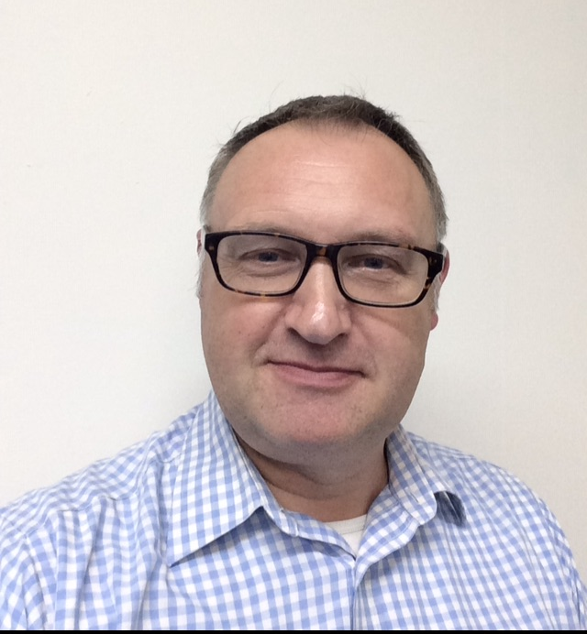

Name (including qualifications): Rev Dr Cameron Langlands BD(Hons), MTh, ThM, PhD

