UKBHC Board Member profiles
Brief account of your experience to date:
Iain was a Part time chaplain for a year in Aberdeen before becoming Lead Chaplain in NHS Highland, a post he held for about 11 years before taking up a secondment opportunity for 18 months in senior management. At the close of this secondment, in November 2010, he worked as Mental Health and Learning Disability Chaplain for NHS Highland. Some Community Chaplaincy work was associated with this role. In November of 2018, Iain took up the post of Programme Director for Chaplaincy and Spiritual Care with NHS Education for Scotland.
With a couple of short breaks, Iain has worked with the UKBHC in its various forms since its inception.

Any role you fulfil on the Board:
Programme Director for Chaplaincy and Spiritual Care in Scotland

What you hope to contribute to the work of UKBHC:
Iain brings 23 years of experience as a Healthcare Chaplain. He has been involved in several significant Chaplaincy documents and publications, such as the Competencies and Capabilities Frameworks (for Chaplains and for Spiritual Care amongst NHS Staff) and the Scottish Journal of Healthcare Chaplain (for which he was on the Editorial Board for eleven years and editor for 3 years). He has also been involved in multi-faith Chaplaincy Team development in Nazareth, Israel. Iain hopes to contribute to the ongoing development of standards, competencies and capabilities within Chaplaincy.

Photograph:

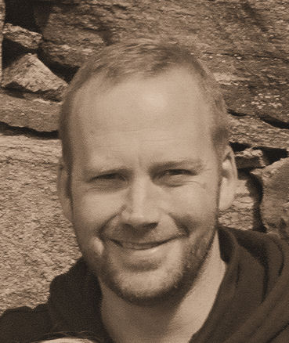

Name: Rev Dr Iain Macritchie BSc BD STM PhD

